VAO OFFICE SYSTEM USING MERN DEVELOPMENT

A MINI PROJECT REPORT

Submitted by

ARIVAZHAGAN.S (820419104007)
DINESH KUMAR.U (820419104020)
NATHISH.B (820419104040)
NAVEEN.K (820419105041)

in partial fulfilment for the award of the degree

of

BACHELOR OF ENGINEERING

IN

COMPUTER SCIENCE AND ENGINEERING

ANJALAI AMMAL MAHALINGAM ENGINEERING COLLEGE KOVILVENNI-614403

ANNA UNIVERSITY:CHENNAI 600 025

ANNA UNIVERSITY:CHENNAI 600 025
BONAFIDE CERTIFICATE

Certified that this project report “VAO OFFICE SYSTEM ” is the bonafide workof“ARIVAZHAGAN.S,DINESHKUMAR.U,NATHIS.B,NAVEEN.K” who carried out the project work under my supervision.

SIGNATURE SIGNATURE

Dr.VELMURUGAN M.E.,MBA.,Ph.D. P.MANIKANDA PRABU.ME.,
HEAD OF THE DEPARTMENT SUPERVISOR
Professor
Department of Computer Science and
Engineering,
Anjalai Ammal Mahalingam
Engineering College,
Kovilvenni - 614403.
Assistant Professor
Department of Computer Science and Engineering,
Anjalai Ammal Mahalingam
Engineering College,
Kovilvenni - 614403.

INTERNAL EXAMINER EXTERNAL EXAMINER

ACKNOWLEDGEMENT

The successful accomplishment of our effort into reality brings us in the fore thought of gratitude to the almighty god who has showered his blessing to us all through our life and this project work.

We convey our deep sense of gratitude to the Managing Trustee Justice.Thiru.A.RAMAMOORTHY. Anjalai Ammal Mahalingam Engineering College . who has given us an opportunity to be a student of his renowned Institution.

We devote our sincere thanks to Dr.S.N.RAMASWAMY M.E., Ph.D., Principal , Anjalai Ammal Mahalingam Engineering College, Kovilvenni. who has given us opportunity to do our project work in an intellectual environment.

We take this opportunity to record our deep sense of gratitude to DR.K.VELMURUGAN M.E.,M.B.A.,Ph.D., Head of the Department, Computer Science and Engineering, indeed he had interest in every student of our department. His motivation and untiring efforts makes us to complete his under Graduate programming successfully in Computer Science and Engineering.

We take this opportunity to record our deep sense of gratitude to Mr.P.MANIKANDA PRABU M.E., Assistant Professor, Department of Computer Science and Engineering, and our project guide for the constant help, encouragement and guidance offered during the course of this project work.
We extend our profound thanks to our parents,family and friends for their moral support extended to us during this project work
ABSTRACT
VILLAGE ADMINISTRATION OFFICE SYSTEM is a another level mode of union office. The system panchayath targeted to the improvement of the villages, and the villagers want to tell our problems using these system. The farmer buy the pestisides in the system. And pay our tax of water,house, ect..,The main goal of the project is to develop a system for the computerized village administration office. The common transaction for tax paymentds ,pestiside bills payment,enrolling a new connectin of water,street light etc are stored into the database and report their issues in the system .

.

TABLE OF CONTENTS

CHAPTER  NO | TITLE | PAGENO
 | ABSTRACT  LIST OF FIGURES  LIST OF TABLES | iv  vii  viii
1 | INTRODUCTION | 1

1.1 Why we choose this project 2

1.2 How it is different from 2

1.3.1 Existing System 3

1.4 Benefits and Application 3

1.4.1 Benefits of Project 4

1.4.2 Application 4

1.4.3 Scope of project 4

1.4.4 Organization of report 4

2 SYSTEM MODULE 5

2.1 Module 5

2.2 Change account information 6

2.2.1 Search reference case 6

2.2.2 Other functionalities 6

2.2.3 Input requirement of system 6

2.3 Output requirement of system 7

3 SYSTEM ANALYSIS 7

4 PLATFORM 9

5 DESIGN CONSIDERATIONS 11

5.1 SOFTWARE REQUIREMENT 11

5.2 HARDWARE REQUIREMENT 12

6 FEASIBILITY STUDY 12

6.1 SDLC 14

6.2 DFD 17

6.3 USE CASE DIAGRAM 19

7 SYSTEM DESIGN 23

7.1 DATABASE 23

7.2 SNAPSHOTS OF PROJECT 24

8 SYSTEM TESTING 27

9 SAMPLE CODING 40

10 CONCLUSION 47

LIST OF FIGURES

S. No | NAME OF THE FIGURES | PAGE  NO
- MERN Architecture 8
- NODE.JS Advantages 10
- SDLC 17
- DFD For USER&ADMIN 18
- Administrator use case diagram 20
- USER use case diagram 20
- Sample Database Snapshot 23
- Instructor portal 24
- Dashboard Page 25
- Upload video page 25
- Add Course Page 26
- Student portal 26
- Course Detail Page 27
- Enrollment Page 27
- Category List Page 28
- Edit User Page 28

LIST OF TABLES
S. No | NAME OF THE FIGURES | PAGE  NO
1 Level of Testing 29

1.INTRODUCTION
The "VAO OFFICE" has been developed to override the problems prevailing in the practicing manual system. This software is supported to eliminate and in some cases reduce the hardships faced by this existing system. Moreover this system is designed for the particular need for indian government to solve the problems which convay to the vao using this to solve the effective manner. The website is reduced as much as possible to avoid errors while give the collection data. It also provides solusion for the complain from the people. No formal knowledge is needed for the user to use this system. Thus by this all it proves it is user-friendly. It can assist the user to concentrate on their other activities rather to concentrate on the record keeping. Thus it will help organization in better utilization of resources. Every organization, whether big or small, has challenges to overcome and managing the information of COMPLAINT who posted,and . Every website has different Assignment needs, therefore we design exclusive employee management systems that are adapted to your managerial requirements. This is designed to assist in strategic planning, and will help you ensure that your organization is equipped with the right level of information and details for your future goals. Also, for those busy executive who are always on the go, our systems come with remote access features, which will allow you to manage your workforce anytime, at all times. These systems will ultimately allow you to better manage resources

1.1 WHY WE CHOOSE THIS PROJECT

To collect issues of area people in village, village administative officer environment by developing an online VILLAGE ADMINISTRATION OFFICE SYSTEM using full-stack development.The main objective behind this project is give the solution for the village people from VAO office.This project is developed for the village peoples the becouse this people have a less education so the project was developed .Future we will add the so many features in this project .

1.3 EXISTING SYSTEM

In the existing system the exams are done only manually.

- Complaints day is coducted weekly once by government of tamil nadu.
- The patision has to be handed over to the concilor oly in paper format.
- people have to go to the municipality offic to report the problem.
- hard to maintain large amount of papers and documents.

1.3 Proposed System of VAO OFFICE SYSTEM
The aim of proposed system is to develop a system of improved facilities. The proposed system can overcome all the limitations of the existing system. The system provides proper security and reduces the manual work.
- Security of data.
- Ensure data accuracy's.
- Proper control of the higher officials.
- Minimize manual data entry.
- Minimum time needed for the various processing.

1.4 APPLICATIONS

VAO OFFICE SYSEM is a method of post a area problems, ,such as the internet or computer-based technologies.It can also be used for a pestisides sales sites.

1.4.1 SCOPE OF THE PROJECT

It may help collecting perfect management in details. In a very short time, the collection will be obvious, simple and sensible. It will help a person to know the management of passed year perfectly and vividly. It also helps in current all works relative to VAO OFFICE System. It will be also reduced the cost of collecting the management & collection procedure will go on smoothly. Our project aims at Business process automation, i.e. we have tried to computerize various processes of VAO OFFICE System.
• In computer system the person has to fill the various forms & number of copies of the forms can be easily generated at a time.
• In computer system, it is not necessary to create the manifest but we can directly print it, which saves our time.
• To assist the staff in capturing the effort spent on their respective working areas.
•To utilize resources in an efficient manner by increasing their productivity through automation.
• The system generates types of information that can be used for various purposes.
• It satisfy the user requirement
• Be easy to understand by the user and operator
• Be easy to operate Have a good user interface
• Be expandable
• Delivered on schedule within the budget

1.4.2 ORGANIZATION OF REPORT

Based on the outline design of the system requirements in terms of inputs, output, Procedures, the technical issues raised during technical feasibility include:

- Does the necessary technology exist to do what is proposed?
- Does the proposed equipment have the technical capacity to hold the data required to use in the new system?
- Adequate responses provided by the proposed system?
- Is the system flexible enough to facilitate expansion?
- Is there any technical guarantee of accuracy, reliability, ease of access and data security?
- The system developer’s task is to view needed capabilities in light of currently available technology. Our site works hand in hand with high technology. A database has to be maintained in order to update and backup data whenever required. To create databases, we use MySQL server.
- For the acceptance within the organization the following points are important and those are explained according to the topics
- Whether the system provides right information to the right place?
- In the current system which is the semi computerized system the information may be lost in the process of sending from one place to another. This is mainly due to human interaction in the process of the transferring information from one place to another. Whether the new system affects the current users in the system?

The new proposed system will affect the users in the following areas:

- Accuracy
- Efficiency
- Productivity

2.SYSTEM MODULE

The modules involved in this project are:
- Admin/faculty
- User/people

2.1 User/people

In this module:

- User can signup
- User can login
- User can set up passwosword
- User can complaint our issues
- User can buy pestisides

2.1.2 Admin/Faculty

In this module:

- Admin can resume user id
- Admin can see all pages
- Admin can maintain all records of user
- Admin can maintain all site
- Admin can access and process all requests
- Admin can delete/update
- Admin Provide all information related to any topic
- Admin can block user id

2.2 CHANGE ACCOUNT INFORMATION

Update Account information like Phone Number , Email ID and their detail.

2.2.1 SEARCH REFERENCE CASE

System will provide an interface for Administrator & Subordinate searching comprehensively the reference information from the videos of application on the basis of various parameters, like Title of videos e.g.HTML.

2.2.2 OTHER FUNCTIONALITIES

System will also provide other functionalities like:
- Feedback
- Request
- FAQ etc.

2.2.3 INPUTS REQUIREMENTS OF THE SYSTEM

- User Information
- Log in Information
- Recent Posts Information
- Registered Information
- Topic Information
- Feedback
- FAQ
- Request

2.3 OUTPUT REQUIREMENTS OF THE SYSTEM

- Novel Information
- Assigned information of users
- Categories information
- FAQ
- Request

2.3.1 MAINTENANCE

The system allows following Maintenance processes

- Manage Recent posts
- Manage users
- Manage images
- Manage Comments
- Manage news
- Security Questions
- Manage Contact us

3.SYSTEM ANALYSIS

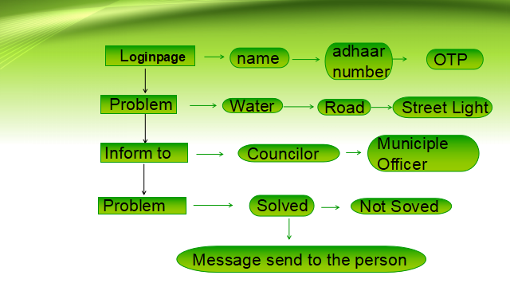

3.1 PROJECT PLANNING
Software project plan can be viewed as the following:
1) Within the organization: How the project is to be implemented? What are various constraints(time, cost, and staff)?
For a successful software project the following steps can be followed:
¬ Select a project
• Identifying project's aims and objectives.
• Understanding requirements and specification
• Methods Of analysis, design and implementation
• Testing techniques
• Documentation
¬ Project milestones and deliverables
o Exceeding limits within control
¬ Project Estimates
o Cost
o Time
o Size of code
o Duration
¬ Resource Allocation
o Hardware
o Software
o Previous relevant project information
o Digital Library
¬ Risk Management
o Risk avoidance and Risk detection

3.3 SYSTEM SECURITY
A secure authentication is required to identify the user who will use the web application and to determine his access privileges. This mechanism prevents the attackers to access another user’s account, to view sensitive information or to perform unauthorized operations. Also, once authenticated, the user should have the possibility to change his password.
Below are listed some good practices regarding authentication:
- Requiring re-authentication at specified time intervals;
- Enforcing the users to set only strong passwords (including some capital letters, at least one number,some special characters, etc);

4.PLATFORM

4.1 TECHNOLOGIES TO BE USED

Platform:

- Front end: REACT JS.
- Back end: Node JS, Mango DB, EXPRESS.JS.
4.1.1 NODEJS

Node.js is an open-source, cross-platform, back-end JavaScript runtime environment that runs on the V8 engine and executes JavaScript code outside a web browser. Node.js lets developers use JavaScript to write command line tools and for server-side scripting—running scripts server-side to produce dynamic web page content before the page is sent to the user's web browser. Consequently, Node.js represents a "JavaScript everywhere" paradigm, unifying web-application development around a single programming language, rather than different languages for server-side and client-side scripts.

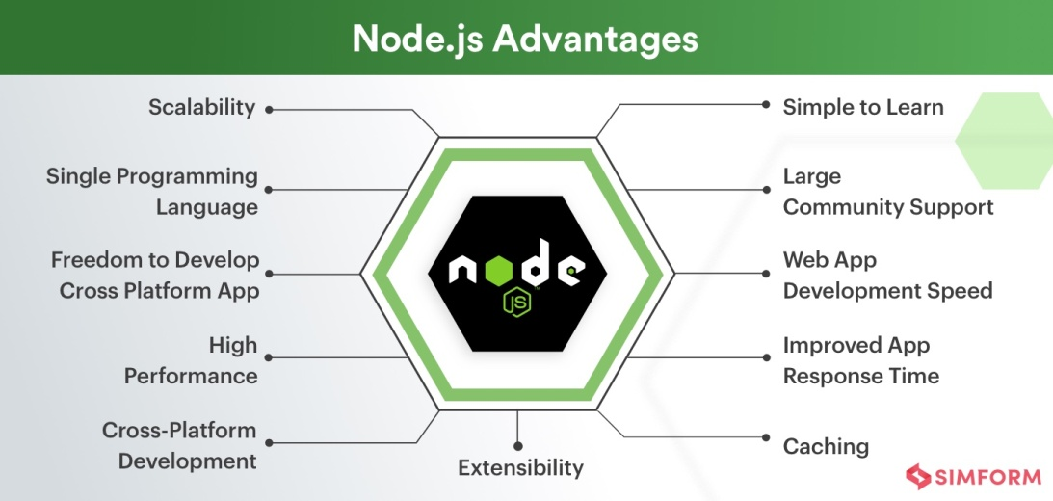

4.1.2 Advantages of Node JS

- Efficient performance.
- Easier development process.
- Reusable code.
- Ability to handle multiple requests.
- Ability to scale smoothly.
- Prompt code execution.
- Asynchronous and event-driven.
- Supported by leading companies

4.2 GitHub

GitHub, Inc. is a provider of Internet hosting for software development and version control using Git. It offers the distributed version control and source code management (SCM) functionality of Git, plus its own features. It provides access control and several collaboration features such as bug tracking, feature requests, task management, continuous integration, and wikis for every project. Headquartered in California, it has been a subsidiary of Microsoft since 2018.It is commonly used to host open-source projects. As of November 2021, GitHub report having over 73 million developers and more than 200 million repositories (including at least 28 million public repositories). It is the largest source code host as of November 2021.

4.3 Mongo DB

MongoDB is a source-available cross-platform document-oriented database program. Classified as a NoSQL database program, MongoDB uses JSON-like documents with optional schemas. MongoDB is developed by MongoDB Inc. and licensed under the Server Side Public License (SSPL) which is deemed non-free by several distributions.

4.4 SCRIPTING LANGUAGES

- HTML, XML, XSL, XHTML
- DHTML – CSS, JavaScript, DOM
- AJAX
- Bootstrap
- ReactJS

5.DESIGN CONSIDERATIONS

5.1Software Requirements

- JDK
◦ JavaScript
- Web Server
◦ GitHub
- Web Scripting Language
◦ Node JS
- Database
◦ MangoDB
- Environment
◦ VS Code
- Supported Operating Systems
◦ Windows 2000/XP/2003/Vista / Windows 7/ Windows 8/ XP64 / Vista64 / Windows 7 64 /Windows 10 64/Windows 11 64

5.2 Hardware Requirements

- Minimum Hardware Configurations
- Minimum Hardware Configurations
- Processor: 800MHz Intel Pentium III or equivalent
- Memory: 512 MB ◦ Disk space: 750 MB of free disk space
- Screen resolution is 1024x768 pixels.

5.2.1 Recommended Hardware Configurations

- Processor: Intel Core i5 or equivalent
- Memory: 2 GB (32-bit), 4 GB (64-bit)
- Disk space: 1.5 GB of free disk space
- Screen resolution is 1024x768 pixels

6.FEASIBILITY STUDY
Best Learning Management System defined the best LMS solution is defined in this study as one in which all LMS components are considered within the total learning such that maximum student success is ensured from both an institutional and System perspective. Aspects of these components within the frame work of student success were assessed by the following attributes:
• Cost effectiveness

The total cost figures included in this report represent a current snapshot of the LMS expenditures excluding self-hosting and migration cost, is reported to the Assessment team. The benefits of the LMS is expected to be more than cost such as hosting maintenance and other cost that may be incurred.
• Support and Training

The system must have a virtual learning community provides students orientates templates and professionals, development resources for faculty by providing online help desk services for students and faculty that includes chat, email, telephone and a personalized support portal available 24/7/365.
• Ease of Use

The LMS must have ease of use components and no additional instrument questions were developed the system should have a higher level of instructor and administrator perceived application functionality.
• Scalability

The LMS must be able to report on the number of active course, users, and average course size and storage capacity on their LMS. It should be able to hold a lot of actives but still be able to use a less storage capacity.
• Sustainability

The sustainability of an LMS is paramount to the future growth of distance learning in the university. The system-wide capability to support LMS-centric learning technology is challenging in both the short and long terms. Information from the success NC listening tour notes indicate that: -
(1) Colleges differ on LMS preferences but want continued support from the System Office.
(2) Learning technology offers an effective and flexible means to facilitate learning.
(3) Increased enrollments have negatively affected instructors, strained facilities, and encouraged creative interventions to maximize resources

6.1 S/W DEVELOPMENT LIFE CYCLE

Every software development consists several phases, have certain predefined works and at the end of each phase document is prepared. This phase is based on certain Software Development Model.

Software Development Model

Software engineering is a discipline that integrates process, methods, and tools for the development of computer software. To solve actual problems in an industry setting, software engineer or a team of software engineers must incorporate a development strategy that encompasses, methods, and tools. This strategy is often referred to as a process model or a software-engineering paradigm.
A number of different process models for the software engineering have been proposed, each exhibiting strengths and weaknesses, but all having a series of generic phases in common. Some of the commonly used software process models are:

- The linear sequential model
- The prototyping models
- The RAD model
- The incremental model
- The spiral model
A particular process model for software engineering is chosen on the nature of the project and the application at hand, the methods and the tools to be used, and the controls are required.
All software development can be characterized as a problem-solving loop in which four distinct stages are encountered:

- Status Quo
- Problem Definition
- Technical Development
- Solution Integration

Software Requirement Analysis
The requirements gathering process is intensified and focused specifically on software. To understand the nature of the program(s) to be built, the software engineer (“analyst”) must understand the information domain for the software, as well as required function, behavior, performance, and interfacing. Requirements for the both the system and the software are documented and reviewed with the customer.

Design

Software design is actually a multi-step process that focuses on four distinct attributes of a program: data structures, software architecture, interface representations, and procedural (algorithm) detail. The design process translates requirement into a representation of the software that can be assessed for quality before code generation begins.

Code Generation

The design must be translated in to a machine-readable form. The testing process focuses on the logical internals of the software, assuring that all statements have been tested and on the functional externals that is, conducting tests to uncover errors and ensure that defined inputs will produce actual results that agree with required results.

Testing
Once code has been generated, program testing begins. The testing process focuses on the logical internals of the software, assuring that all statements have been tested and on the functional externals that is, conducting tests to uncover errors and ensure that defined inputs will produce actual results that agree with required results.

Maintenance

Software will undoubtedly undergo change after it is delivered to the customer (A possible exception is embedded software). Change will occur because errors have been encountered, because the software must be adapted to accommodate change in its external environment (e.g., A change required because of a new operating system or peripheral device), or because the customer requires functional or performance enhancements.

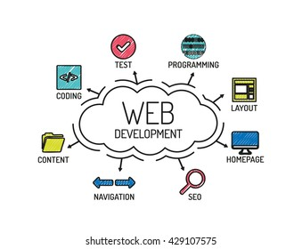
6.2 DATA FLOW DIAGRAM (DFD)
Data flow diagrams model the flow of data into, though, and out of an information system:
- Show the processes that change or transform data.
- Show the movement of data between processes.
- Represent a system as a network of processes which transform data flowing between them.
DATA FLOW DIAGRAM FOR VAO OFFICE SYTEM

login

Check user
User
Home page
Yes

No
Registration
page

6.2.1 SYSTEM REQUIREMENTS

System requirements are what is necessary for a client to install the web application in their system and be used hopefully without any difficulties. The aim of this is to help clients make sure they have all required tools or equipment. With analysis there are some objectives for hardware, software and any other thing that would be the minimum requirements to install the system.

6.2.1.1 System Evaluation

In is in the very hope that by the end of the implementation of this system 97 percent of the problems faced in the by the current system shall be resolved and it will meet all user requirement, user friendly as users were involved in all stages of the development system. In this system there are three main users which are the administrator, the lecture and the student, each one of them has their specific task and roles they can perform within the system. The system is sensitive to privacy protection thereby the system has been designed to observe these matters.

6.2.1.2 Administrator/Faculty

- The system administrator will have full access privilege of the system which the other users cannot perform. Some of these include: - assigning roles to user (who is the Admin, lecture or student), deleting users, adding (department, faculties), and lastly creating users.
- The lecture will have the privileges of uploading and downloading documents, posting news about (test, class, and assignments), start blogs for discussions and upload results (coursework).

6.2.1.3 PEOPLE USER

The student will have less privileges, the student will be able to upload and download documents, comment on the blogs created by lectures, and view posts news by lectures, and administrators, and lastly students will be able to view their PROBLEM STATE.

6.3 USE CASE DIAGRAM
Use cases are used during the analysis phase of a project to identify system functionality. They separate the system into actors and use cases. Actors represent roles that are played by users of the system. Users may be humans, other computers, or even other software system.

Administrator use case
ADIMIN &USER
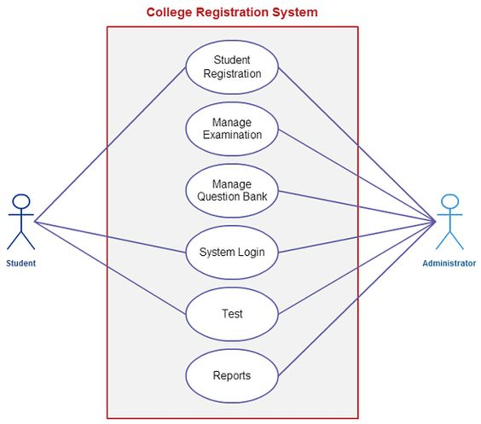
ADMIN
USER
Issue problem state
Put data for user
Accept user
Report issues
Login
Verify user detail

USER use case
REGISTER
LOGIN

BUY PESTISIDES
POST ISSUE

USER
LOGOUT

6.3.1 Object Oriented Analysis

Object–Oriented Analysis (OOA) is the procedure of identifying software engineering requirements and developing software specifications in terms of a software system’s object model, which comprises of interacting objects. In the system analysis or object-oriented analysis phase of software development, the system requirements are determined, the classes are identified and the relationships among classes are identified. The three analysis techniques that are used in conjunction with each other for object-oriented analysis are object modelling, dynamic modelling, and functional modelling.

6.3.1.1 Object Modelling

Object modelling develops the static structure of the software system in terms of objects. It identifies the objects, the classes into which the objects can be grouped into and the relationships between the objects. It also identifies the main attributes and operations that characterize each class. The process of object modelling can be visualized in the following steps:

- Identify objects and group into classes
- Identify the relationships among classes
- Create user object model diagram
- Define user object attributes
- Define the operations that should be performed on the classes

6.3.1.2 Dynamic Modelling

After the static behavior of the system is analyzed, its behavior with respect to time and external changes needs to be examined. This is the purpose of dynamic modelling. Dynamic Modelling can be defined as “a way of describing how an individual object responds to events, either internal events triggered by other objects, or external events triggered by the outside world”. The process of dynamic modelling can be visualized in the following steps:

- Identify states of each object
- Identify events and analyze the applicability of actions
- Construct dynamic model diagram, comprising of state transition diagrams
- Express each state in terms of object attributes
- Validate the state–transition diagrams drawn

6.3.1.3 Functional Modelling

Functional Modelling is the final component of object-oriented analysis. The functional model shows the processes that are performed within an object and how the data changes as it moves between methods. It specifies the meaning of the operations of object modelling and the actions of dynamic modelling. The functional model corresponds to the data flow diagram of traditional structured analysis. The process of functional modelling can be visualized in the following steps:

- Identify all the inputs and outputs
- Construct data flow diagrams showing functional dependencies
- State the purpose of each function
- Identify constraints
- Specify optimization criteria

7.System Design

7.1 Database

Data base is used to store the relevant information of the individuals. A database is a collection of rows and columns in which rows indicates the tuple and column indicates the domain of table. Database design is the process of producing a detailed data model of a database. This logical data model contains all the needed logical and physical design choices and physical storage parameters. Need to generate a design in a data definition language, which can then be used to create a database. A fully attributed data model contains detailed attributes for each entity. The term database design can be used to describe many different parts of the design of an overall database system. Principally, and most correctly, it can be thought of the logical design of the relation of the base data structures used to store the data. In the relational model these are the classes and named relationships. However, the term database design could also be used to apply to overall process of designing, not just the base data structure, but also the forms and queries used as part of the overall database application within the database management system (DBMS).
It includes eight tables namely,

- Admin
- Videos
- Category
- Comment
- Contact
- News

7.1.1 REGISTER PAGE

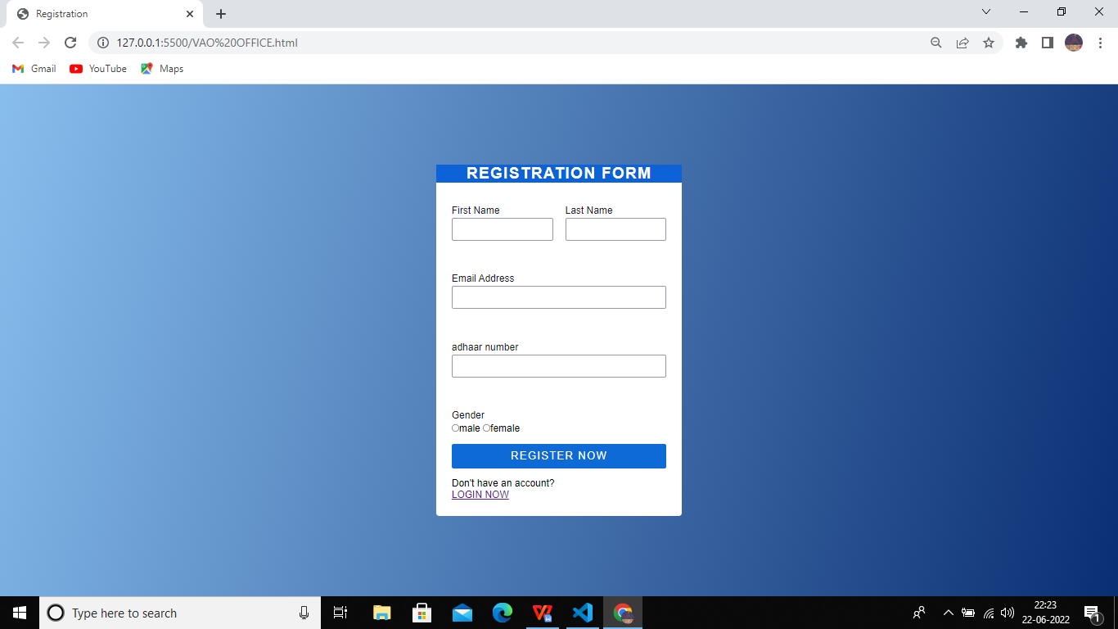

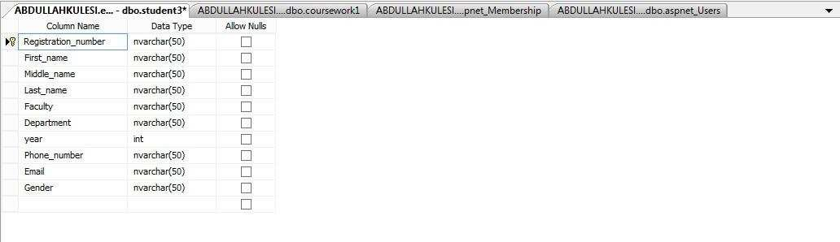

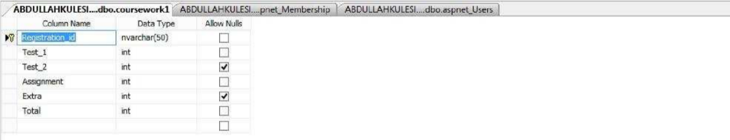

7.2 SNAPSHOTS OF PROJECT
7.2.1 LOGIN PORTAL

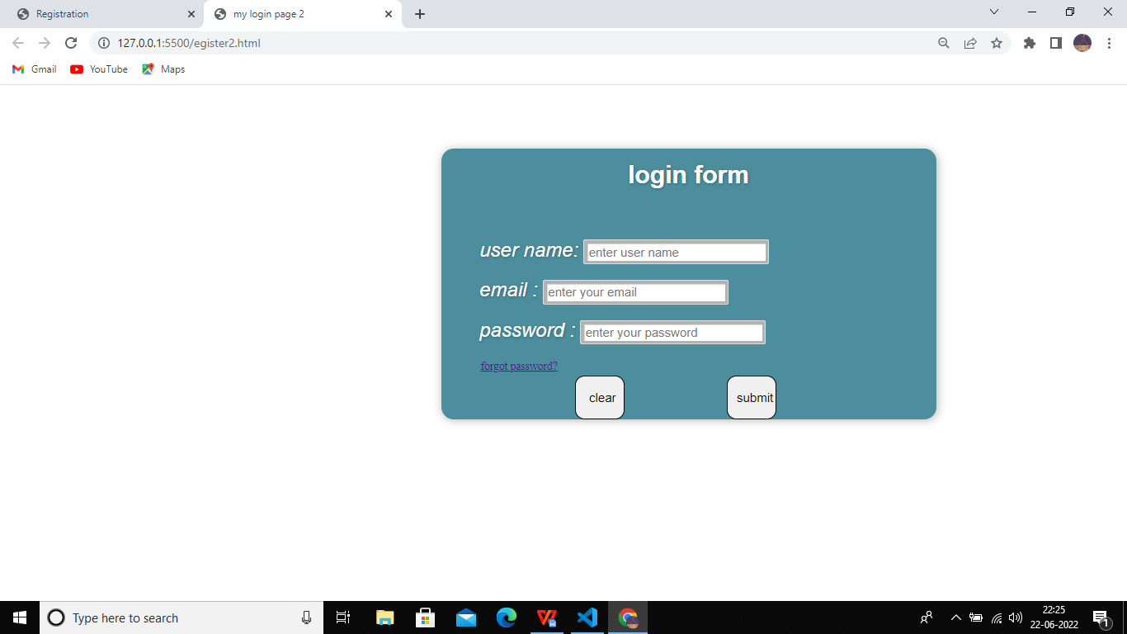

7.2.2.SET UP PASSWORD
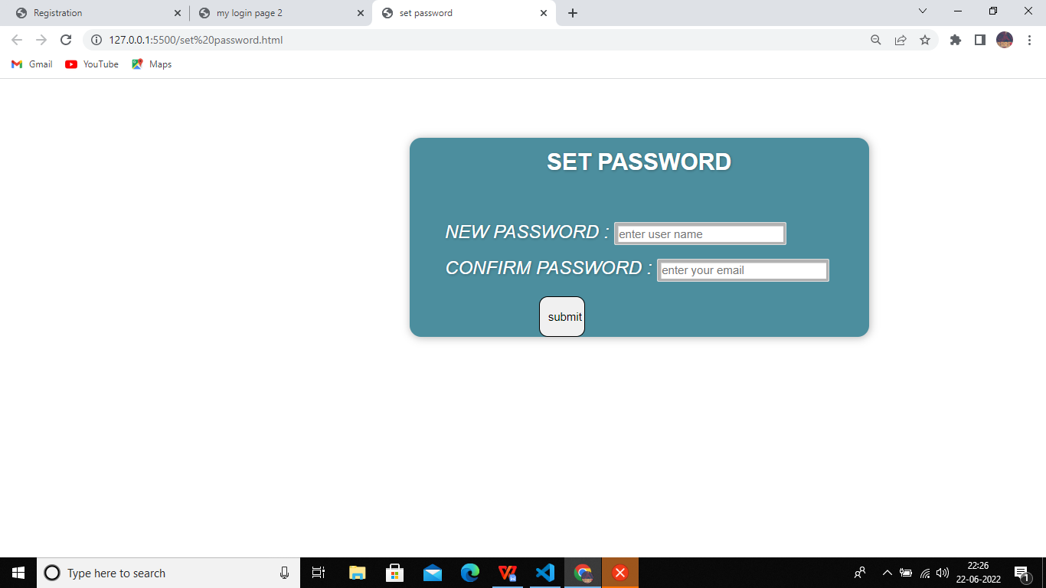

7.2.3 Upload the issue
Upload the issue
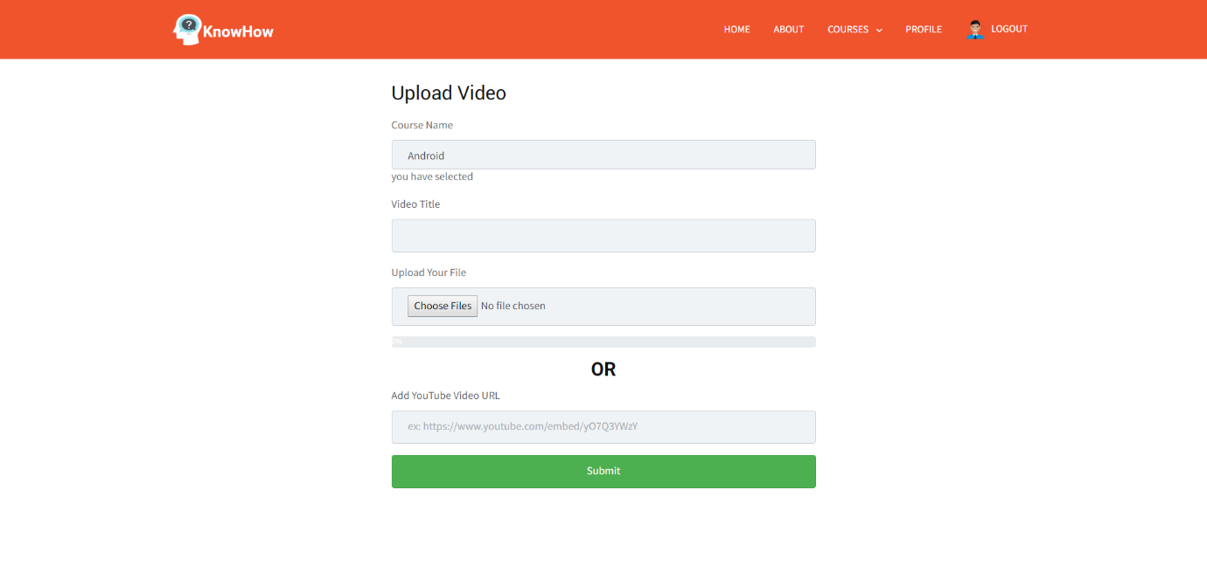
submit
Upload the issue

7.2.5.PRODUCT LIST(PESTISIDES)
Buy pestiside
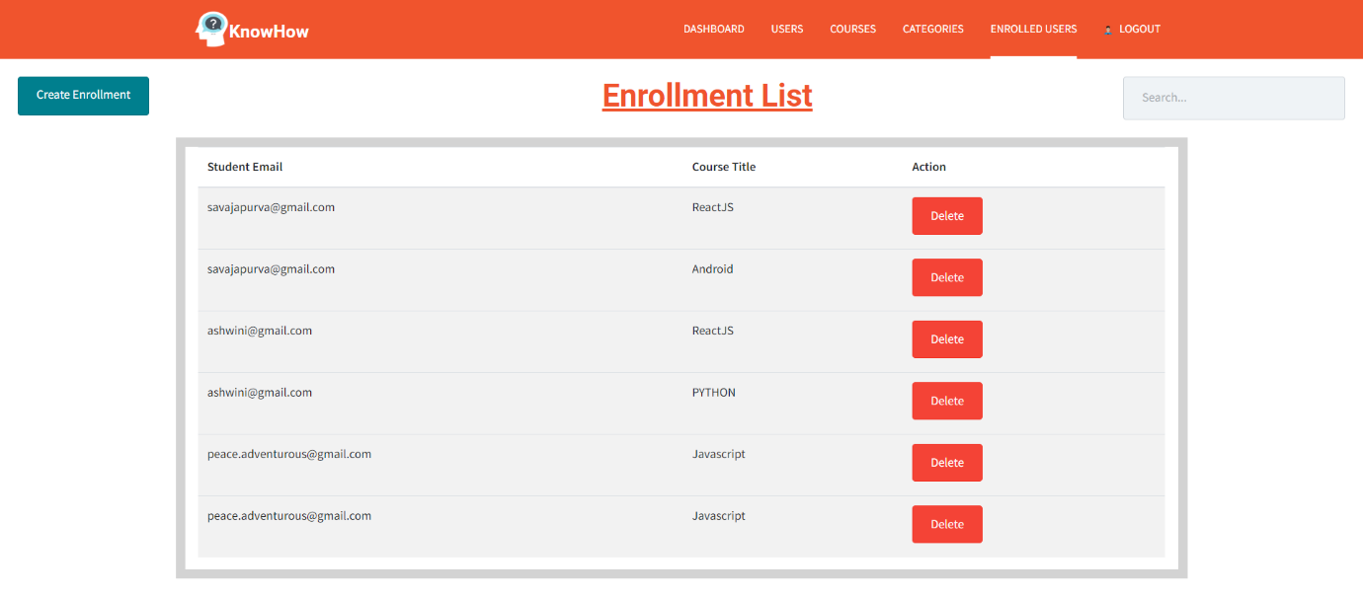
Product list
buy
buy
buy
buy
buy
buy

8.SYSTEM TESTING

System testing is a critical element of quality assurance and represents the ultimate review of analysis, design and coding. Test case design focuses on a set of techniques for the creation of test because that meet overall testing objective. When a system is developed it is hoped that it performs properly. The main purpose of testing an information system is to find the errors and correct them. The scope of system testing should include both manual and computerized operations. System testing is comprehensive evaluation of the programs, manual procedures, computer operations and controls.
System testing is the process of checking whether the developed system is working according to the objective and requirement. All testing is to be conducted in accordance to the test conditions specified earlier. This will ensure that the test coverage meets the requirements and that testing is done in a systematic manner.

8.1 TEST CHARACTERS

1. A good test has a high probability of finding an error.
2. A good test is not redundant.
3. A good test should be “best of breed”

8.2 Levels Of Testing

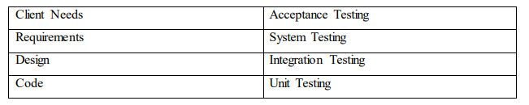
Fig No:1 Levels Of Tesing
8.3 BLACK BOX TESTING

The method of Black Box Testing is used by the software engineer to derive the required results of the test cases:
1.Black Box Testing alludes to test that are conducted at the software interface. Client Needs Acceptance Testing Requirements System Testing Design Integration Testing Code Unit Testing
2.A Black Box Test examines some fundamental aspect of a system with little regard for the internal logic structure of the software.
3.A limited number of important logical paths can be selected and exercised.
Black box testing was performed to find errors in the following categories:-

- Incorrect or missing functions
- Graphics error.
- Errors in data in binary format.
- Error in data in integer format.
- File error.
- Pointer error
- Variable error

8.4 WHITE BOX TESTING

White Box Testing is sometimes called Glass Box Testing. Using White Box Testing methods, the software engineer can derive the following test cases:

- Guarantee that all independent paths within a module have been exercised at least once.
- Exercise all logical decisions on their true and false sides.
- Execute all loops at their boundaries and within their operational bounds.

In White Box Testing efforts were made to handle the following:

- Number of input parameters equal to number of arguments
- Parameters and arguments attributes match.
- Number of arguments transmitted is called modules equal to attributes of parameters. •Unit system of argument transmitted is called modules equal unit system of parameter. • Number of attributes and order of arguments to build in functions correct.
- Any references to parameters not associated to build in functions correct.
- Input only arguments altered
- Global variable definition consistent across module.
- Files attributes correct

8.5 Unit Testing

Code testing was carried out to see the correctness of the logic involved and the correctness of the modules. Tests were conducted based upon sample and live data as well. All the modules are checked separately for assuming correctness and accuracy in all the calculations.

8.6 Specification Testing

It examines the specification stating about what program should do and how it performs under various conditions. This testing strategy is better strategy since it focuses on the way the software is expected to work.

8.7 Integration Testing

The next level testing that was performed is often referred to as integration testing. During this phase many unit tested modules were combined into subsystems, which were then tested. The goal here was to see if modules can be integrated properly. Here the emphasis was on testing interfaces between different constituent modules of system.

8.9 Functionality Testing

Here the entire software system was tested. The reference document for this process is the requirements document, and the goal was to see if software solution meets its requirements. This level of testing is essentially a validation exercise, and in many situations, it is the only validation activity.

8.10 Stress Testing

Proxy server developed for the specified purpose was testing under heavy load, i.e. a large no. of clients were made to sit in lab and were asked to send requests for logging in and then were asked to request for text on internet. System responded to request as desired.

8.11 Acceptance Testing

Acceptance was performed in the real environment with realistic data of the client to demonstrate if the software developed is working satisfactorily. Here the main focus was on the external behavior of the system; the internal logic of the program was not emphasized.

8.12 Test Data and Test Cases

The primary objective of test case design is to derive a set of tests that have the highest likelihood of uncovering errors in software. The test case specification is the major activity in the testing process. Careful selection of test cases that satisfy the criterion on approach specified is essential for proper testing. Various characteristics of test cases that are required for portal are:
    - A good test has a high probability of finding an error.
    - A good test is not redundant.
    - A good test should be “Best of Breed”.
    - A good test should be neither too simple not too complex.

8.13Overview of Testing

8.13.1 Testing

Testing involves executing the program (or part of it) using sample data and inferring from the output whether the software performs correctly or not. This can be done either during module development (unit testing) or when several modules are combined (system testing).

8.13.2 Direct Testing

Defect testing is testing for situation where the program does not meet its functional specification. Performance testing tests a system's performance or reliability under realistic loads. This may go some way to ensuring that the program meets its nonfunctional requirements.

8.13.3 Debugging

Debugging is a cycle of detection, location, repair and test. Debugging is a hypothesis testing process. When a bug is detected, the tester must form a hypothesis about the cause and location of the bug. Further examination of the execution of the program (possible including many returns of it) will usually take place to confirm the hypothesis. If the hypothesis is demonstrated to be incorrect, a new hypothesis must be formed. Debugging tools that show the state of the program are useful for this, but inserting print statements is often the only approach. Experienced debuggers use their knowledge of common and/or obscure bugs to facilitate the hypothesis testing process. After fixing a bug, the system must be reset to ensure that the fix has worked and that no other bugs have been introduced. This is called regression testing. In principle, all tests should be performed again but this is often too expensive to do.

8.13.4 Test Planning

Testing needs to be planned, to be cost and time effective. Planning is setting out standards for tests. Test plans set out the context in which individual engineers can place their own work. Typical test plan contains

8.13.5 Interface Testing

Usually done at integration stage when modules or sub-systems are combined. Objective is to detect errors or invalid assumptions about interfaces between modules. Reason these are not shown in unit testing is that test case may perpetuate same incorrect assumptions made by module designer. Particularly important when OO development has been used.

Four Types Of Interface

- Parameter: data (or occasionally function references) passed from one unit to another.
- Shared memory: block of memory shared between units (e.g., global variable). One places data there and the other retrieves it.
- Procedural: Object-Oriented or abstract data type form of interface, encapsulating several procedures.
- Message passing: one sub-system requests a service by passing a message. Client-server interface also used by some OO architectures.

Typical levels of testing

Acceptance testing - whole system with real data (involve customer, user, etc.). Alpha testing is acceptance testing with a single client (common for bespoke systems). Beta testing involves distributing system to potential customers to use and provide feedback. In, this project, Beta testing has been followed. This exposes system to situations and errors that might not be anticipated by us.

8.13.6 Maintenance

Once the website is launched, it enters the maintenance phase. All systems need maintenance. Maintenance is required because there are often some residual errors remaining in the system that must be removed as they are discovered. Maintenance involves understanding the effects of the change, making the changes to both the code and the documents, testing the new parts and retesting the old parts that were not changed.
Maintenance is mainly of two types:

- Corrective Maintenance
- Adaptive Maintenance

8.13.6.1 Corrective Maintenance

Almost all software that is developed has residual errors or bugs in them. Many of these surfaces only after the system have been in operation, sometimes for a long time. These errors once discovered need to be removed, leading to the software to be changed. This is called Corrective Maintenance.

8.13.6.2 Adaptive Maintenance

Even without bugs, software frequently undergoes change. The software often must be upgraded and enhanced to include more features and provide more services.

8.13.6.3 Perfective Maintenance

It includes modifications and updates done in order to keep the software usable over long period of time. It includes new features, new user requirements for refining the software and improve its reliability and performance.

8.13.6.4 Preventive Maintenance

This includes modifications and updating to prevent future problems of the software. It aims to attend problems, which are not significant at this moment but may cause serious issues in future.

8.13.6.5 Cost of Maintenance

Reports suggest that the cost of maintenance is high. A study on estimating software maintenance found that the cost of maintenance is as high as 67% of the cost of entire software process cycle.

On an average, the cost of software maintenance is more than 50% of all SDLC phases. There are various factors, which trigger maintenance cost go high, such as:

Real-world factors affecting Maintenance Cost

- The standard age of any software is considered up to 10 to 15 years.
- Older software’s, which were meant to work on slow machines with less memory and storage capacity cannot keep themselves challenging against newly coming enhanced software’s on modern hardware.
- As technology advances, it becomes costly to maintain old software
- Most maintenance engineers are newbie and use trial and error method to rectify problem.
- Often, changes made can easily hurt the original structure of the software, making it hard for any subsequent changes.
- Changes are often left undocumented which may cause more conflicts in future.

Software-end factors affecting Maintenance Cost

• Structure of Software Program
• Programming Language
• Dependence on external environment
• Staff reliability and availability

Maintenance Activities

IEEE provides a framework for sequential maintenance process activities. It can be used in iterative manner and can be extended so that customized items and processes can be included.

These activities go hand-in-hand with each of the following phase:

- Identification & Tracing - It involves activities pertaining to identification of requirement of modification or maintenance. It is generated by user or system may itself report via logs or error messages. Here, the maintenance type is classified also.
- Analysis - The modification is analyzed for its impact on the system including safety and security implications. If probable impact is severe, alternative solution is looked for. A set of required modifications is then materialized into requirement specifications. The cost of modification/maintenance is analyzed and estimation is concluded.
- Design - New modules, which need to be replaced or modified, are designed against requirement specifications set in the previous stage. Test cases are created for validation and verification.
- Implementation - The new modules are coded with the help of structured design created in the design step. Every programmer is expected to do unit testing in parallel.
- System Testing - Integration testing is done among newly created modules. Integration testing is also carried out between new modules and the system. Finally the system is tested as a whole, following regressive testing procedures.
- Acceptance Testing - After testing the system internally, it is tested for acceptance with the help of users. If at this state, user complaints some issues they are addressed or noted to address in next iteration.
Delivery - After acceptance test, the system is deployed all over the organization either by small update package or fresh installation of the system. The final testing takes place at client end after the software is delivered. Training facility is provided if required, in addition to Legacy software cannot keep tuning with the latest technology available in the market. As the hardware become obsolete, updating of software becomes a headache. Even if software grows old with time, its functionality does not.
- the hard copy of user manual.
- Maintenance management - Configuration management is an essential part of system maintenance. It is aided with version control tools to control versions, semi version or patch management.

Software Re-engineering

When we need to update the software to keep it to the current market, without impacting its functionality, it is called software re-engineering. It is a thorough process where the design of software is changed and programs are re-written.

For example, initially Unix was developed in assembly language. When language C came into existence, Unix was re-engineered in C, because working in assembly language was difficult.

Other than this, sometimes programmers notice that few parts of software need more maintenance than others and they also need re-engineering

Re-Engineering Process

- Decide what to re-engineer. Is it whole software or a part of it?
- Perform Reverse Engineering, in order to obtain specifications of existing software.
- Restructure Program if required. For example, changing function-oriented programs into object-oriented programs.
- Re-structure data as required.
- Apply Forward engineering concepts in order to get re-engineered software. There are few important terms used in Software re-engineering

Reverse Engineering

It is a process to achieve system specification by thoroughly analyzing, understanding the existing system. This process can be seen as reverse SDLC model, i.e. we try to get higher abstraction level by analyzing lower abstraction levels.

An existing system is previously implemented design, about which we know nothing. Designers then do reverse engineering by looking at the code and try to get the design. With design in hand, they try to conclude the specifications. Thus, going in reverse from code to system specification.

Program Restructuring

It is a process to re-structure and re-construct the existing software. It is all about rearranging the source code, either in same programming language or from one programming language to a different one. Restructuring can have either source code restructuring and data-restructuring or both.

Re-structuring does not impact the functionality of the software but enhance reliability and maintainability. Program components, which cause errors very frequently can be changed, or updated with re-structuring.

The dependability of software on obsolete hardware platform can be removed via restructuring.

Forward Engineering

Forward engineering is a process of obtaining desired software from the specifications in hand which were brought down by means of reverse engineering. It assumes that there was some software engineering already done in the past.

Forward engineering is same as software engineering process with only one difference – it is carried out always after reverse engineering.

Component reusability

A component is a part of software program code, which executes an independent task in the system. It can be a small module or sub-system itself.

Example:

The login procedures used on the web can be considered as components, printing system in software can be seen as a component of the software.

Components have high cohesion of functionality and lower rate of coupling, i.e. they work independently and can perform tasks without depending on other modules.

In OOP, the objects are designed are very specific to their concern and have fewer chances to be used in some other software.

In modular programming, the modules are coded to perform specific tasks which can be used across number of other software programs.

There is a whole new vertical, which is based on re-use of software component, and is known as Component Based Software Engineering (CBSE).

Re-use can be done at various levels

•Application level - Where an entire application is used as sub-system of new software.
•Component level - Where sub-system of an application is used.
•Modules level - Where functional modules are re-used. Software components provide interfaces, which can be used to establish communication among different components.

Reuse Process:

Two kinds of method can be adopted: either by keeping requirements same and adjusting components or by keeping components same and modifying requirements.

•Requirement Specification - The functional and non-functional requirements are specified, which a software product must comply to, with the help of existing system, user input or both.
• Design - This is also a standard SDLC process step, where requirements are defined in terms of software parlance. Basic architecture of system as a whole and its subsystems are created.
•Specify Components - By studying the software design, the designers segregate the entire system into smaller components or sub-systems. One complete software design turns into a collection of a huge set of components working together.
•Search Suitable Components - The software component repository is referred by designers to search for the matching component, on the basis of functionality and intended software requirements.
•Incorporate Components - All matched components are packed together to shape them as complete software.

9.SAMPLE CODING

Frontend dashboard

<DOCTYPE html>
<html>
<head>
<title>
Registration
</title>
<link rel="stylesheet" type="text/css" href="access.css">
</head>
<body>
<form action="http://127.0.0.1:5500/login%20form.html"></div>
<div class="wrapper">

<div class="registration_form">
<!-- Title -->
<div class="title">
Registration Form
</div>

<!-- Form -->
<form>
<div class="form_wrap">
<div class="input_grp">

<!-- Frist name input Place -->
<div class="input_wrap">
<label for="fname">First Name</label>
<input type="text" id="fname" required>
</div>

<!-- Last Name input place -->
<div class="input_wrap">
<label for="lname">Last Name</label>
<input type="text" id="lname"required>
</div>
</div><br><br>

<!-- Email Id input Place -->
<div class="input_wrap">
<label for="email">Email Address</label>
<input type="text" id="email" required>
</div> <br><br>
<!--ADHAAR NUMBER-->
<div class="input_wrap">
<label for="email">adhaar number</label>
<input type="text" id="adhaar" required>
</div> <br><br>
<!-- Gender Select box -->
<div class="input_wrap">
<label for="gender">Gender</label>
<input type="radio" name="gender"char name="m">male
<input type="radio" name="gender" name="f">female <br>
</div>

<!-- Submit button -->
<div class="input_wrap">
<input type="submit" value="Register Now" class="submit_btn">
</div>
<div class="text">Don't have an account?
<div class="text"><a href="http://127.0.0.1:5500/egister2.html">LOGIN NOW</a>
</div>
</div>
</div>
</form>
</div>
</div>
</body>
</html>

Login page
<DOCTYPE html>
<html>
<head>
<title>
my login page 2
</title>
<link rel="stylesheet" type="text/css" href="control.css">
</head>
<body>
<form action="http://127.0.0.1:5500/egister2.html"></form>
<div class="main">
<div class="register">
<h2>login form</h2>
<form id="register" method="post">
<label>user name:</label>
<input type="text" name="fname" id="name" placeholder="enter user name">
<br><br>
<label>email :</label>
<input type="text" name="lname" id="name" placeholder="enter your email">
<br> <br>
<label>password :</label>
<input type="password" name="password" id="name" placeholder="enter your password">
<br><br>
<div class="text"><a href="http://127.0.0.1:5500/set%20password.html">forgot password?</a></div>
<div class="button input-box">
<i class="fas fa-envelope"></i>
<button style="font-size: 20px;margin-bottom:auto;height: 70;width:
80; border-radius: 15px; padding-left: 10px;margin-left: 150px">clear</button>
<button onclick="validcap()" style="font-size: 20px;margin-bottom:auto;
height: 70;width: 80;border-radius: 15px;padding-left: 10px;margin-left: 160px;">submit</button>
</div>
</form>
</body>
</html>

Set up password
<DOCTYPE html>
<html>
<head>
<title>
set password
</title>
<link rel="stylesheet" href="sequence.css">
<body>
<div class="main">
<div class="register">
<h2>SET PASSWORD</h2>
<form id="register" method="post">
<label>NEW PASSWORD :</label>
<input type="text" name="fname" id="name" placeholder="enter user name">
<br><br>
<label>CONFIRM PASSWORD :</label>
<input type="text" name="lname" id="name" placeholder="enter your email">
<br> <br>
<div class="button input-box">
<i class="fas fa-envelope"></i>
<button onclick="validcap()" style="font-size: 20px;margin-bottom:auto;height: 70;width: 80;border-radius: 15px;padding-left: 10px;margin-left: 160px;">submit</button>
</div>
</form>
</body>
</html>

Back end

import React, { Component } from "react";
import NavBar from "../components/NavBar";
import CanvasJSReact from "../canvas/canvasjs.react"

import axios from "axios";

var CanvasJS = CanvasJSReact.CanvasJS;
var CanvasJSChart = CanvasJSReact.CanvasJSChart;

var dd=[];
class Dashboard extends Component {
constructor(props) {
super(props);
// initialize the state with an empty todos array
this.state = {c1: [],c2:[],c3:[]

};
}
getCoursedata(){
axios.get('http://localhost:5000/courses/')
.then(response => {

var dict={};
dd=[];
response.data.forEach(element => {
//console.log(element);
if( dict[element.instructor.email] == undefined){
dict[element.instructor.email] = 1;
}
else{
dict[element.instructor.email] += 1;
}

});

for( var k in dict){
dd.push({ y : dict[k], label: k })
}
console.log(dd);

this.setState({ c1: dd });
dd=[]
dict={}

response.data.forEach(element => {
//console.log(element);label
if( dict[element.category.categoryName] == undefined){
dict[element.category.categoryName] = 1;
}
else{
dict[element.category.categoryName] += 1;
}

});

for( var k in dict){
dd.push({ y : dict[k], name: k })
}
console.log(dd);

this.setState({ c3: dd });
})
.catch(function (error){
console.log(error);
})
}

getEnrollmentdata(){
axios.get('http://localhost:5000/enrollments/')
.then(response => {

var dict={};
dd=[];
response.data.forEach(element => {
//console.log(element);
if( dict[element.course.courseName] == undefined){
dict[element.course.courseName] = 1;
}
else{
dict[element.course.courseName] += 1;
}

});

for( var k in dict){
dd.push({ y : dict[k], label: k })
}
console.log(dd);
this.setState({ c2: dd });
})
.catch(function (error){
console.log(error);
})
}

componentDidMount() {

this.getCoursedata()
this.getEnrollmentdata()

}

render() {

const options1 = {
exportEnabled: true,
animationEnabled: true,
title: {
text: "Courses Per Instructor"
},
data: [{
type: "pie",
startAngle: 75,
toolTipContent: "<b>{label}</b>: {y}",
showInLegend: "true",
legendText: "{label}",
indexLabelFontSize: 16,
indexLabel: "{label} - {y}",
dataPoints: this.state.c1

}]
}

const options2 = {
exportEnabled: true,
animationEnabled: true,
title: {
text: "Students Per Course"
},
data: [
{
// Change type to "doughnut", "line", "splineArea", etc.
type: "column",
dataPoints: this.state.c2
}
]
}

const options3 = {
exportEnabled: true,
animationEnabled: true,

title: {
text: "Courses Per Category"
},
subtitles: [{

verticalAlign: "center",
fontSize: 24,
dockInsidePlotArea: true
}],
data: [{
type: "doughnut",
showInLegend: true,
indexLabel: "{name}: {y}",
yValueFormatString: "#,###",
dataPoints:this.state.c3
}]
}

return (
<div>
<NavBar />

<div className='container'>
<tr className='row'>
<th className="col-md-6">
<CanvasJSChart options = {options1}
/* onRef={ref => this.chart = ref} */
/>
</th>
<th className="col-md-6">
<CanvasJSChart options = {options3}
/* onRef={ref => this.chart = ref} */
/>
</th>
</tr>
<br></br>
<div className="row">
<CanvasJSChart options = {options2}
/* onRef={ref => this.chart = ref} */
/>
{/You can get reference to the chart instance as shown above using onRef. This allows you to access all chart properties and methods/}
</div>
</div>
</div>
);
}
}

export default Dashboard

11.CONCLUSION

Our project is only a humble venture to satisfy the needs to manage their project work. Several user-friendly coding have also adopted. This package shall prove to be a powerful package in satisfying all the requirements.

“THE SOUL OF INDIA LIVES IN ITS VILLAGES”
-Mohandas karamchand
gandhi

REFERENCE

1. Kristina Chodorow(2018)- MongoDB: The Definitive Guide
2. Robin Wieruch(2016)- The Road to Learn React
3. Thomas Powell(2017)- HTML & CSS: The Complete Reference, Fifth Edition Paperback

